Parents/Carers and children fill in this booklet together. It helps the staff get to know your child in preparation for starting school in September.

Poulton Lancelyn Primary School
All about me
Add a recent picture of your child here

My full name is_________________________________________
I would like to be known as ____________________________________
I am______________years old.
My birthday is _______________________________________

My Family – (Tell us about your family, who you live with, brothers, sisters, pets etc)
__________________________________________________________________________________________________________________________________________________________________________________________________________________________________________________________________________________________________________________________________________________________________________________________________________________________________________________________________________________________________________________________________________________________________________________________________________________________________________________________________________________
My Favourite things:
My favourite game is…...
I like to eat and drink……

My favourite television programme is……
My favourite toy is……

My favourite song or rhyme is……
My favourite book is……

What do you like to do at home and in pre-school? (e.g. painting, Lego, writing, use computer, play in sand and water, dancing, looking at books etc.)

Additional Information
My child will be brought to school and picked up by:-
Name _______________________________Contact Phone Number__________________
Name _______________________________Contact Phone Number__________________
Name _______________________________Contact Phone Number__________________
My child has allergies, medical conditions or takes regular medication. Yes / No
(If yes please tell us about what they are)
___________________________________________________________________________________________________________________________________________________________________________________________________________________________
My child can’t eat or drink e.g. milk
__________________________________________________________________________________________________________________________________________________
My child previously attended
___________________________________________________________________________________________________________________________________________________________________________________________________________________________
My child is shy when
___________________________________________________________________________________________________________________________________________________________________________________________________________________________
My child gets upset or frightened when
___________________________________________________________________________________________________________________________________________________________________________________________________________________________
My child is confident when
___________________________________________________________________________________________________________________________________________________________________________________________________________________________
My child finds it difficult to
___________________________________________________________________________________________________________________________________________________________________________________________________________________________
Is there anything else you would like to tell us about your child/family?
________________________________________________________________________________________________________________________________________________________________________________________________________________________________________________________________________________________________________________________________________________________________________________________________________________________________________________________________________________________________________________________________________________________________________________________________________
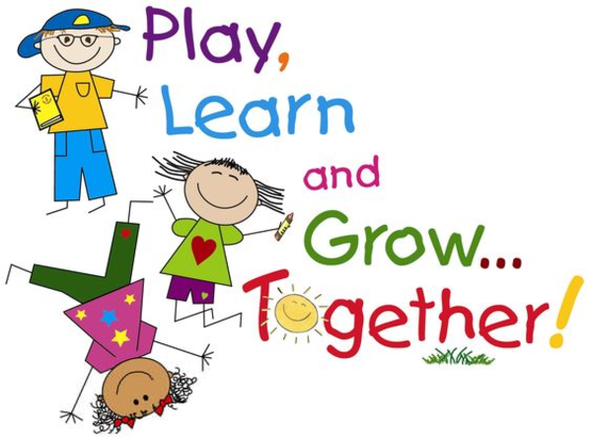
Thank You
F2 Team

