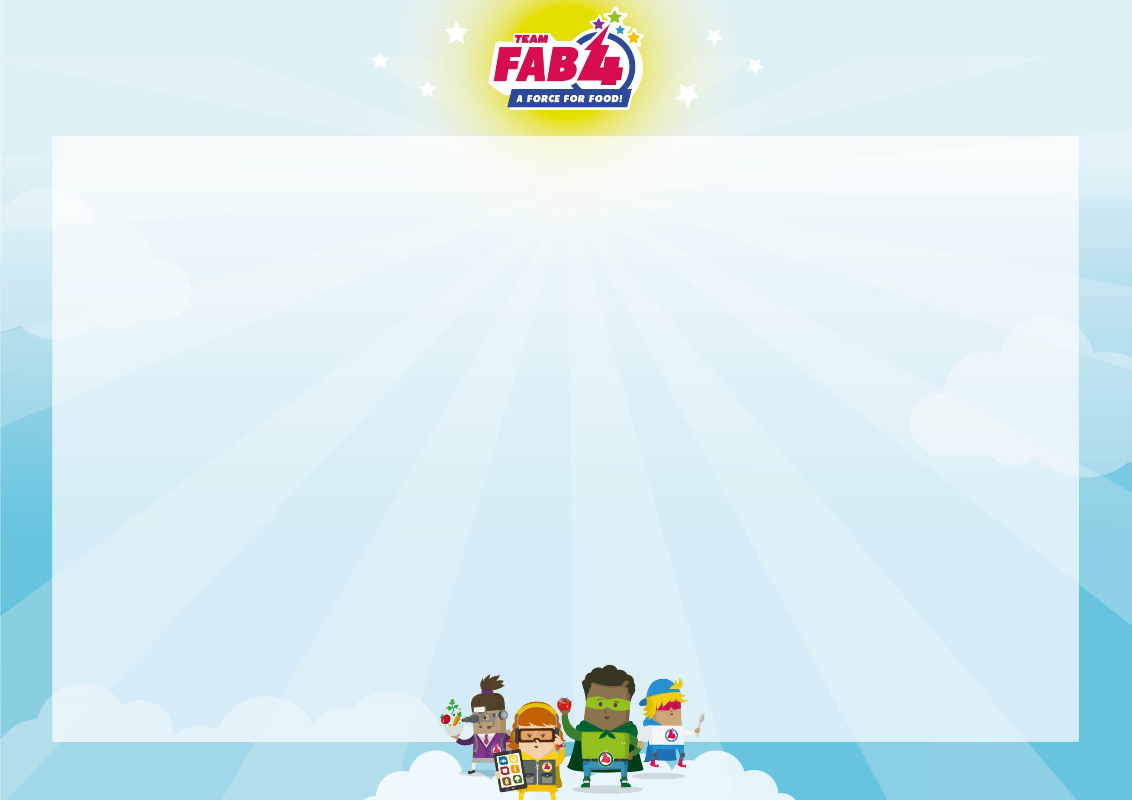
Spring – Summer Classroom Menu

Week One
Poulton
 | MONDAY | TUESDAY | WEDNESDAY | THURSDAY | FRIDAY
Main Meal Option | Freshly Baked Jacket Potato with your Choice of Toppings: Tuna & Mayonnaise, Grated Cheese, Baked Beans (V) | Cheesy Topped Chicken Fillet & Baked New Potatoes | Roast of the Day with Yorkshire Pudding, Roast Potatoes  (No Gravy) | Wholemeal Cheese & Tomato Pizza With ½  Jacket Potatoes (V) | Fish & Chips with Tomato Sauce
Vegetarian Main Meal Option |  | Cheesy Topped Baked Quorn | Quorn Roast with Yorkshire Pudding, Roast  Potatoes  (No Gravy) | Hunters Vegetable Flatbread | Veggie Nuggets & Chips with tomato sauce
Jacket/Handheld Option | Packed Lunch Bag  Sandwich Selection, choose from Ham, Cheese or Tuna | Packed Lunch Bag  Sandwich Selection, choose from Ham, Cheese or Tuna | Hot Roast Baguette | Hunters Chicken Flatbread | Cheddar Wheel
Vegetable Selection | Garden Peas  Carrots | Sweetcorn  Broccoli | Cauliflower  Savoy Cabbage | Carrots  Roasted Vegetables | Baked Beans  Garden Peas
Dessert | Lemon Drizzle Cake | Chocolate Crispy Cake | Fruit Salad | Fruit Sponge | Sultana & Cherry Flapjack with Apple Wedges

Salad Selection, Fresh Bread, Fresh Fruit & Yoghurts
 | MONDAY | TUESDAY | WEDNESDAY | THURSDAY | FRIDAY
Main Meal Option | Toad in the Hole with Mash | Beef Burrito & Jacket Wedges | Roast Of The Day With Stuffing, Roast Potatoes  (No Gravy) | American Style Baked  Chicken & Crispy Diced Potatoes | Crispy Battered Fish & Chips with Tomato  Sauce
Vegetarian Main Meal Option | Vegetarian Toad in the Hole with Mash | Wholemeal Cheese & Tomato Pizza with ½ Jacket Potato | Quorn Roast with Stuffing, Roast Potatoes  (No Gravy) | Tomato & Basil Pasta with Garlic Bread | Vegetable & Bean Grill
Jacket/Handheld Option | Packed Lunch Bag  Sandwich Selection, choose from Ham, Cheese or Tuna | Ploughman’s Lunch | Hot Roast Bap | Freshly Baked Jacket Potato with your Choice of Toppings: Tuna & Mayonnaise, Grated Cheese, Baked Beans | Pepperoni Pizza & Chips
Vegetable Selection | Green Beans  Carrots | Sweetcorn  Roasted Summer Vegetables | Peas  Carrots | Spring Cabbage  Cauliflower | Mushy Peas  Baked Beans
Dessert | Fruit Salad | Banana Traybake | Fruit & Jelly | Ginger Biscuit & Orange  Wedges | Chocolate Cookie
Spring – Summer Classroom Menu

Salad Selection, Fresh Bread, Fresh Fruit & Yoghurts
Poulton
Week Two

 | MONDAY | TUESDAY | WEDNESDAY | THURSDAY | FRIDAY
Main Meal Option 1 | Beef Burger in a Bun & Baked New Potatoes | Wholemeal Cheese & Tomato Pizza with ½ Jacket Potato (V) | Roast of the Day with Yorkshire Pudding, Roast Potatoes  (No Gravy) | Great British Breakfast - Bacon, Scrambled Eggs, Beans &  Mushrooms | Fish Fingers & Chips with Tomato Sauce
Vegetarian Main Meal Option 1 | Veggie Burger & Baked New Potatoes |  | Quorn Roast with Yorkshire Pudding, Roast Potatoes  (No Gravy) | Meat Free All Day Breakfast – Veggie Sausage, Scrambled Eggs, Beans & Mushrooms | Veggie Nuggets & Chips with Tomato Sauce
Jacket/Handheld Option | Freshly Baked Jacket Potato with your Choice of Toppings: Tuna & Mayonnaise, Grated Cheese, Baked Beans | Packed Lunch Bag  Sandwich Selection, choose from Ham, Cheese or Tuna | Hot Roast Wrap | Packed Lunch Bag  Sandwich Selection, choose from Ham, Cheese or Tuna | Cornish Pasty
Vegetable Selection | Sweetcorn  Steamed Carrots | Green Beans  Broccoli | Savoy Cabbage  Cauliflower | Roasted Carrots  Roast Peppers & Sweetcorn | Baked Beans  Garden Peas
Dessert | Shortbread Biscuit | Chocolate Brownie | Jelly | Iced Carrot Cake & Orange Wedges | Apple Sponge
Spring – Summer Classroom Menu
Salad Selection, Fresh Bread, Fresh Fruit & Yoghurts

Week Three
Poulton

