Poulton Lancelyn

Work Pack

Year 1

Contents

English
Reading
Complete reading bingo
Complete comprehension
School reading books
Writing
Story retell
Character description

Spelling
Spelling sheets

Maths

Mathletics
Measurements

Science
Weather

Foundation Subjects
RE Easter story
Geography Our local area
History Family interviews
Science Seasons and weather
DT Memory box
Computing Coding

Other links
Reading

Reading bingo
Complete as many reading activities as you can on our bingo sheet. You can record this reading in your yellow reading log.

Reading comprehension
Read the texts about dogs and answer the corresponding comprehension questions.

Reading of school books
Read your school books and record them in your reading log. You can also record any additional reading you do.

RWI sounds
Use the RWI complex sound chart to practise each sound.

Writing
Story retell
Watch the following link to remind yourselves of our story Wilfrid Gordon McDonald Partridge
https://www.youtube.com/watch?v=usnOEnTXabw&safe=true

Write a retell of the story, thinking about the order of the events and how each memory made Wilfrid and Miss Nancy feel. Use the example of the story map to help you plan your ideas prior to writing. Alternatively, you could write a story retell about an another book you have at home.

Character description
Read our class character description of Miss Nancy. Use this to help you write a description about one of the other characters from the book. Consider what the character looks like, what you think their personality is like and what you think they might like doing. Try to make your sentences exciting by using lots of interesting descriptive words. Alternatively, you could write a description about a character from an another book you have at home.

Y1 writing skills

- Capital letters and full stops
- Capital letters for names
- Use the joining word ‘and’ (you could also use or, but, so)
- Use the suffixes ‘ing’, ‘ed’ or ‘er’
- Use ‘s’ or ‘es’ to make singular nouns plural
- Use your Fred fingers for spelling
- Using exclamation and question marks

Handwriting
Can you use the RWI handwriting chart to practise your letter formation?

Spelling

- Learn to spell the following words for the correct week (on our website) and ask an adult to test you on Friday.

- Use spelling frame for 10 minutes each day.

- We have also included a list of red words. How many of these words can you read and spell?

Maths

- Complete Mathletics tasks which have been set and keep checking Mathletics each day for new tasks.

- Play live on Mathletics for at least 10 minutes every day.

- Measure – use a ruler or tape measure around your house to records lengths of objects in non-standard (e.g. tins, wooden blocks, lego bricks) is and standard units of measurements (cm)

- Measure – use kitchen scales to weigh some ingredients in your kitchen (grams). Can you weigh out the correct ingredients to bake a cake?

- Measure – find 5 different containers. Use a measuring jug to work out how much liquid each container holds in non-standard (e.g. cups, egg cups, bowls) and standard units (l, ml). Work out which container holds the most water and which container holds the least.

- Measure – practise telling the time (o’clock and half past)

- Daily calculations and number work (addition, subtraction, one more/one less, ordering and comparing numbers, counting in 2s, 5s and 10s)
Science
Can you be a weather watcher?
Keep a weather diary for a week. Include the date, types of weather and temperature. Watch weather forecasts on the news and record yourself presenting your own weather forecast.
https://www.youtube.com/watch?v=Uo8lbeVVb4M

Foundation Subjects

RE
Find out about what happened on Palm Sunday, Good Friday and Easter Sunday. If your family celebrates Easter, the way that you celebrate Easter and any family traditions that you have.

Geography
Using Google Maps, look at different views of our local area. Look for any human or physical features you can see using the aerial view. Can you find the route you would take from your house to school? Can you draw your own aerial view map?

History
Use the questions we created as a class to interview different members of your family about their childhood. Find out about what school, games and technology was like when they were a child. How does it compare to your own experiences?

DT
Look at different boxes you have around your house. What are they used for? How do they open? Is it secure? Look at the pictures on our box hunt sheet. Can you find any of these types of boxes in your house? You can record your answers on our sheet or on a piece of paper.
Use the template we have given you to create your own memory box.

Computing
Think about the skills you used to complete levels on the Alex the Robot and Box Island apps. Can you practise these skills to find your way out of the maze? https://blockly.games/maze?lang=en

Jack Hartmann
Maths, exercise and brain break videos.
https://www.youtube.com/channel/UCVcQH8A634mauPrGbWs7QlQ?safe=true

Cosmic Kids
Yoga and mindfulness
https://www.youtube.com/channel/UC5uIZ2KOZZeQDQo_Gsi_qbQ?safe=true

Go Noodle
Dance and mindfulness videos
https://www.youtube.com/user/GoNoodleGames?safe=true

Art for Kids Hub
Directed drawings
https://www.youtube.com/user/ArtforKidsHub?safe=true

Topmarks
Maths games
https://www.topmarks.co.uk/

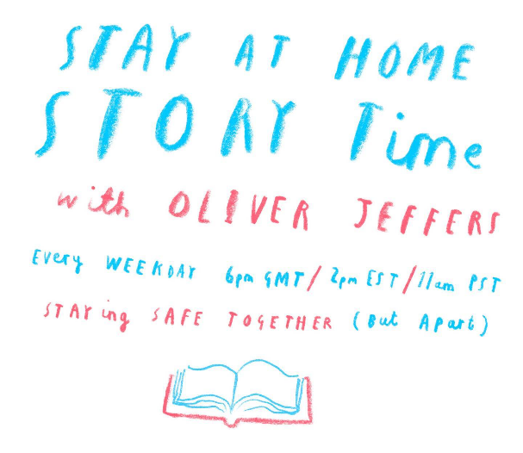
Epic
Online books and quizzes
https://www.getepic.com/

Alphablocks and Numberblocks
https://www.bbc.co.uk/cbeebies/shows/alphablocks
https://www.bbc.co.uk/cbeebies/shows/numberblocks

NRICH
Maths challenges
https://nrich.maths.org/primary

Stories in Space
Watch astronauts read stories in space
https://storytimefromspace.com/science-experiments-overview/

Cincinnati Zoo
Daily Facebook videos about different animals

National Trust
If you have access to a garden and it is safe to go outside, you could have a go at some of these activities.
https://www.nationaltrust.org.uk/features/50-things-to-do-before-youre-11--activity-list

