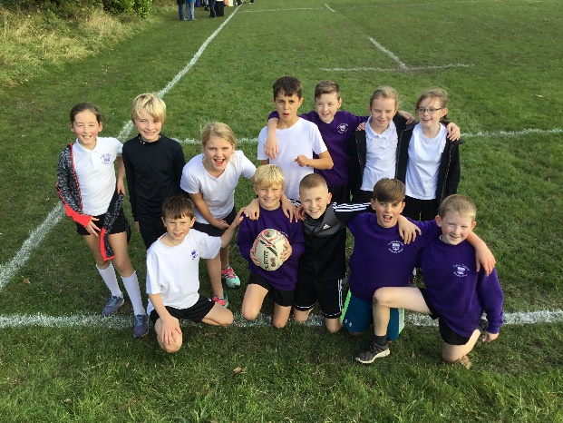
Match Report – TAG Rugby
Festival
Birkenhead Park RUFC
Tuesday 8th October 2019

On a beautiful autumn afternoon Mr Arnold & Mrs Sims took the TAG Rugby team to Birkenhead Park for a festival to celebrate the Rugby World Cup 2019. When we got there everyone was very excited and a few people were very nervous too. We were representing South Africa as our nation in the World Cup and we would play against St. Peter’s Heswall ‘A’ & ‘B’ (England); Lingham (New Zealand); Oxton St Saviour’s (France) and Our Lady of Pity ‘A’ & ‘B’ (Italy).

We lost our first game was against Our Lady of Pity ‘A’ team 3-0, they were very strong and experienced, a team full of Year 6 players and unfortunately, we were slow starters – as usual! Next up we played another big team from Oxton St Saviour’s who seemed a little ‘liberal’ with some of the rules, although we played much better we were narrowly beaten again, but we did manage a really excellent team try scored by Thomas B.

Next up we played a strong Our Lady of Pity ‘B’ team who were really strong and had some interesting decisions go their way, we lost that one 4-1 with Isaac B getting on the scoresheet. Our next fixture was against the eventual winners of the whole tournament St Peter’s ‘A’ Team, we were magnificent in defence and attack and we were the only team that they were unable to score a try against. We won the game 1-0 with a fabulous try from Josh T who eventually ran a brilliant support line and finished in the corner.

We were now on a roll and ramped up our performance to beat a strong Lingham team – who had three really strong players – 3-2 with tries from Isaac B, Josh T and Lucas H. Our final game was against St Peter’s ‘B’ team and it was an end to end affair, and they were awarded two tries that were dropped over the line. To our absolute credit we accepted the referee’s decision and played on with respect and pride. We ended up drawing the match 3-3, with tries from Fraser M, Lucas H and Thomas B.

Well done to all the children who represented the school so well.

